Develop an architectural proof of concept for a python application using docker. You are expected perform below activities.

Dockerfile content -screenshot

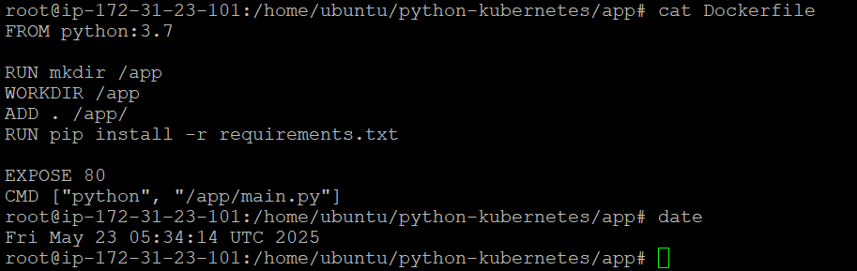

Docker run command screenhot

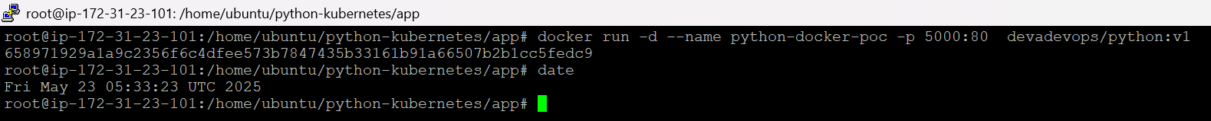

Curl <http://localhost:5000> – screenshot

